### Regular Expressions Results

If you use the following regular expressions what will be a possible result?

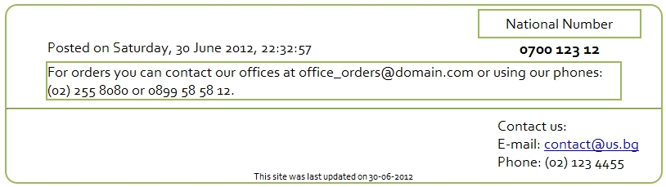

|  |  |
| --- | --- |
| Regular Expression | Result (Xpath) |
| [A-z0-9._%+-]+@[A-z0-9.-]+\.[A-z]{2,4} | Email addresses |
| \(+[0-9]{2}+\)+\s+[0-9]{3}+\s+[0-9]{4} | Phone numbers (i.e. (02) 255 8080) |
| \d{4}\s\d{3}\s\d{2} | Toll-free numbers (i.e. 0700 123 12) |
| \d{2}-\d{2}-\d{4} | Date (i.e. 30-06-2012) |
| \w+\,+\s+\d{1,2}\s+\w+\s+\d{4}\,+\s+\d{2}\:\d{2}\:\d{2} | Date (i.e. Saturday, 30 June 2012, 22:32:57) |